The principles for creating Java programming were

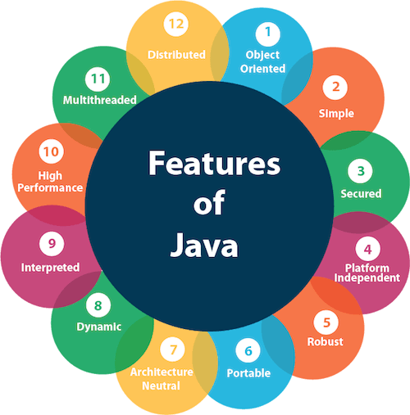

Java is a **programming language** and a **platform**.

**Platform**: Any hardware or software environment in which a program runs, is known as a platform. Since Java has a runtime environment (JRE) and API, it is called a platform.

Java was developed by Sun Microsystems (which is now the subsidiary of Oracle) in the year 1995.

James Gosling is known as the father of Java.

There are three types of variables in java: local, instance and static.

There are two types of [data types in Java](https://www.javatpoint.com/java-data-types): primitive and non-primitive.